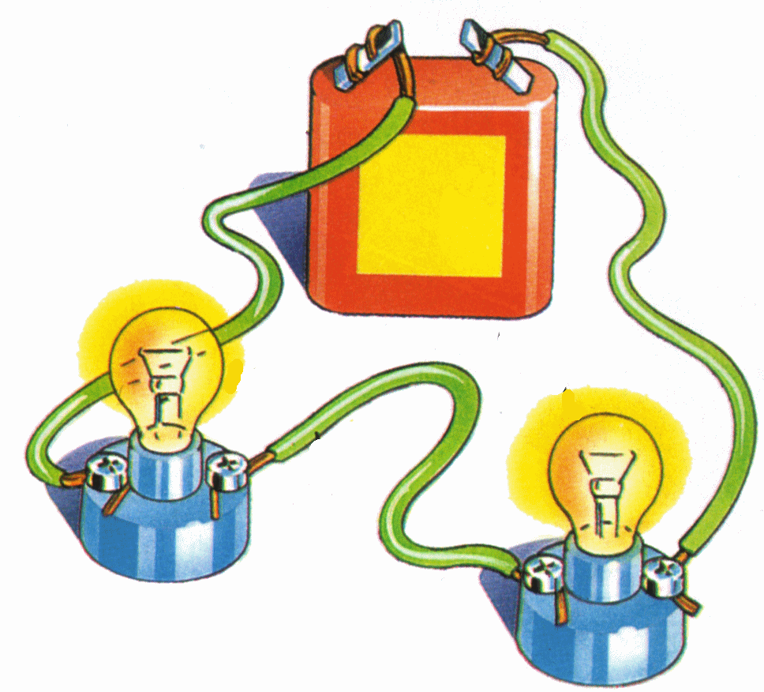
Communication
Please feel free to reach out to Coach Thompson at any time using the following methods:
dthompson@cisd.org
903-874-8211
BE RESPECTFUL

BE RESPONSIBLE

BE RELIABLE
Materials
- Pencil and/or Pen
- Composition Book

Donations:
- Elmer’s Glue
- Tissues
Units Covered
Unit 1: Properties of Matter
Unit 2: Elements and the Periodic Table
Unit 3: Nuclear Reactions
Unit 4: Solutions
Unit 5: Chemical Reactions
Unit 6: Position, Speed, Acceleration
Unit 7: Forces and Momentum
Unit 8: Potential and Kinetic Energy
Unit 9: Thermal Energy
Unit 10: Waves
Unit 11: Electricity
Unit 12: Energy Resources
Grading
  - Tests 50%
  - Labs 30%
  - Daily 20%
*Progress Reports will be sent home every three weeks.

*Students will have a Midterm Exam for the end of the fall semester and a Final exam at the end of the Spring semester.

*Students will be offered test corrections as an opportunity to bring up their test grades.
Objective
In Integrated Physics and Chemistry, students conduct laboratory and field investigations, use scientific practices during investigation, and make informed decisions using critical thinking and scientific problem solving. This course integrates the disciplines of physics and chemistry in the following topics: force, motion, energy, and matter.
Integrated Physics and Chemistry
Syllabus
Coach Thompson C205

Coach Thompson’s Schedule
Period | Class | Time
1st | Athletics | 8:20 – 9:10
2nd | Conference | 9:14 – 9:59
3rd | IPC | 10:03 – 10:48
TCC | TCC Time | 10:48 – 11:00
4th | Chemistry | 11:04 – 11:49
5th | IPC | 11:53 – 1:23
6th | IPC | 1:27 – 2:12
7th | IPC | 2:16 – 3:01
8th | Athletics | 3:05 – 3:50

Please SIGN and RETURN this page by Aug. 20st
Signature Page
I am available to all parents and students before school and during my conference period. Please contact me about any concerns or questions that you may have. My email is dthompson@cisd.org.
As a teacher, I am responsible for providing instruction in IPC. I will do so by providing opportunities for tutorials and extra help, by teaching laboratory safety, by encouraging my students to achieve at their highest ability, by sending progress reports home to parents every three weeks, and by communicating with parents by telephone whenever necessary.
Teacher Darrell Thompson Date August 14, 2019

As a student, I will be responsible for coming to class with my supplies, completing assignments on time, adhering to all safety rules, and following all school and classroom policies.
I have read and I understand the lab safety contract, the grading policies, and the course syllabus for this class.
PRINT STUDENT NAME:
STUDENT SIGNATURE:
DATE:

As a parent, I will be responsible for encouraging my child to complete their work and to prepare for each class day. I will communicate with the instructor whenever necessary.
I have read and I understand the lab safety contract, the grading policies and the course syllabus for this class.
PRINT PARENT NAME:
PARENT SIGNATURE:
DATE:
Telephone Number of Parent during School Hours:
E-mail Address:

